IRIS Client-Sync Overview

Contents

System Structure 1
Elements of the IRIS Client-Sync System 2
Dashboard and DSR Components 2
Plug-ins 2
Process Flowchart 4

System Structure

IAO Database

Dashboard

ICE Database

Import / Export Plug-ins

Domain Specific Relay
(DSR)

Send
Receive

Email

Domain Specific Relay
(DSR)
of target system

The Dashboard is the main user-interface, and allows the user to see what actions, if any, are currently in progress, to instigate exports, accept pending imports, set up schedules, etc.

The Domain Specific Relay (DSR) is the main controller for the system, and runs as a Windows service. It looks for incoming Client-Sync emails, for requests from the Dashboard, and handles scheduled actions and sending outgoing Client-Sync emails.

The ICE Database (an MS SQL Server Express 2005 database) is used by the DSR to maintain and store information about past, active, and pending actions.

The Import/Export Plug-ins handle the actual transfer of data to and from the main IRIS database files. Data is transmitted in XML format, and the plug-ins are responsible for reading and writing the XML documents.

On export, the documents are either passed directly to the DSR, or are stored in files and the filenames are passed to the DSR. The DSR then packages the XML documents into compressed email attachments, and sends them to the target system. The DSR at the target system receives the email attachments and stores them ready for import.

When the import is accepted by the user (via the Dashboard) the attachments are uncompressed and reconstituted back into XML documents, which are then passed to the Import plugins. The Import plugins transfer the data from the documents to the main IRIS database files.

Elements of the IRIS Client-Sync System
Installing IRIS Accounts Office will also install the Microsoft .NET Framework (if it is not already installed) and SQL Server Express 2005, both of which are required by the Client-Sync system.

Dashboard and DSR Components
The following components are installed in the main company directory:

Element | Notes
Config.exe | Configuration utility. On installation, the database settings and the various folders will be automatically filled in. The email set-up, however, must be entered by the end user before the DSR can be used.
Dashboard.exe | The Dashboard program, which is the main user interface for the Client-Sync system.
DSR.dll | Main DSR facilities, and the DSR Windows Service.
DSRUtility.dll | Additional DSR facilities.
ICSDMode.dll | Dripfeed mode plugin for IRIS Accounts Office, preventing editing of transactions which are in the drip-feed period range.
Interop.DSR.dll | Allows communication between .NET and non .NET components.
IRIS.ICE.Common.dll | Provides facilities used by both the DSR and by the Client-Sync plugins.
RemotingClientLib.dll | .NET component for communicating between processes (such as between the Dashboard and the DSR).
Bulk.ini | This lists the plugins required for a bulk import/export, in the order in which they must be called. The import requires the plugins to be run in a specific order, to ensure that the related data required by (for example) transactions has already been imported
Dashboard.ini | Dashboard settings.
DSR.ini | DSR settings
Mail.ini | Email settings used by the DSR.

Plug-ins

Plugins are installed in the Plugins folder. For the Client-Sync, the following plug-ins are installed:

Plug-in DLL | Notes | OLE Automation Server
DSRExport.dll | Base COM object for export plug-ins.
DSRImport.dll | Base COM object for import plug-ins.
ICSExDri.dll | COM object for Drip-feed export. | IrisClientSync.DripFeedDataExporter
ICSExMat.dll | COM object for Matching export. | IrisClientSync.MatchingDataExporter
ICSExSta.dll | COM object for Static Data export. | IrisClientSync.StaticDataExporter
ICSExSys.dll | COM object for System Data export. | IrisClientSync.SystemDataExporter
ICSExTra.dll | COM object for Transaction Data export. | IrisClientSync.TransactionDataExporter
ICSImDri.dll | COM object for Drip-feed import. | IrisClientSync.DripFeedDataImporter
ICSImMat.dll | COM object for Matching import. | IrisClientSync.MatchingDataImporter
ICSImSta.dll | COM object for Static Data import. | IrisClientSync.StaticDataImporter
ICSImSys.dll | COM object for System Data import. | IrisClientSync.SystemDataImporter
ICSImTra.dll | COM object for Transaction Data import. | IrisClientSync.TransactionDataImporter

The System, Static, Transaction, and Matching importers/exporters handle the bulk import and export. The Dripfeed importers/exporters handle import and export for dripfeed mode.

Process Flowchart
This shows the basic flow of messages and data between a Client system and a Practice system, from the point where the Client first requests a data synchronisation through to the point where the synchronisation is stopped.

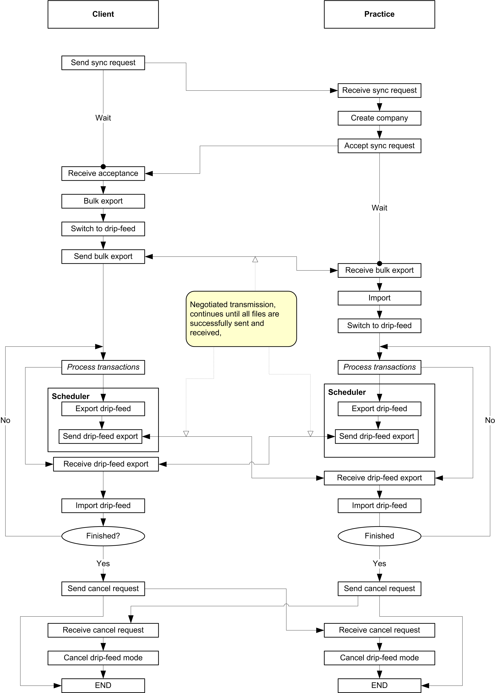

Note that once the system is in Dripfeed mode, both sides can send and receive transactions (which is why the diagram becomes rather ‘busy’ at that point), though it is normally the Client who will be doing most of the sending.

